Experiment-6
Step1: Switch On the TP-Link Router.
Step2: Open a browser and enter TPlinkrouter's IP address-192.168.0.1
Step-3:Login using the password-cmrit@1234
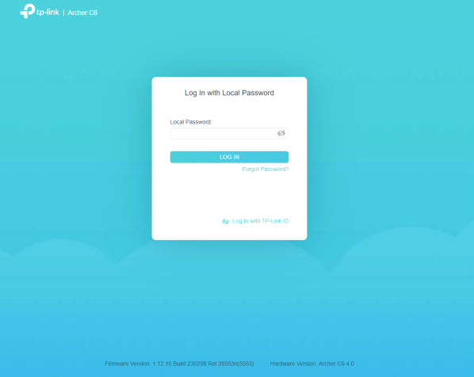
Step-4:Home page
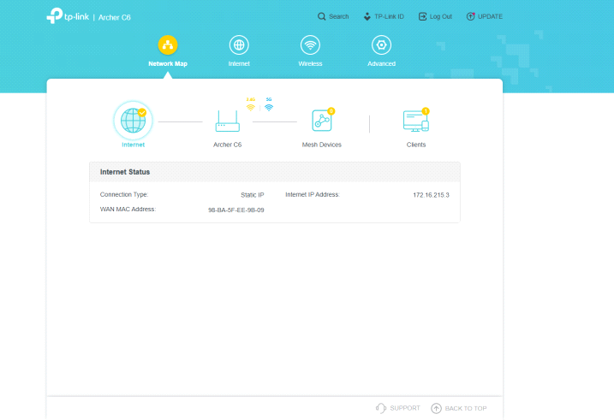
Step-5:Goto Wireless tab and Enable Smart Connect.
Select security (WPA2-PSK[AES]+WPA-PSK|TK) and enter SSID and Password and click on save button.
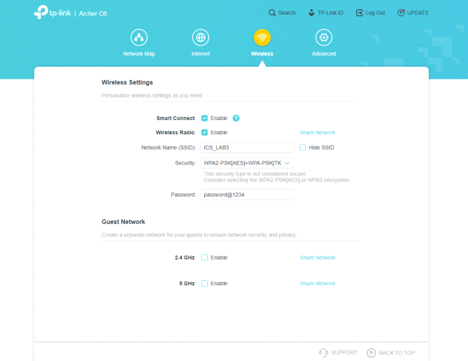
Step-6: Goto Advanced tab,select security and then select access control
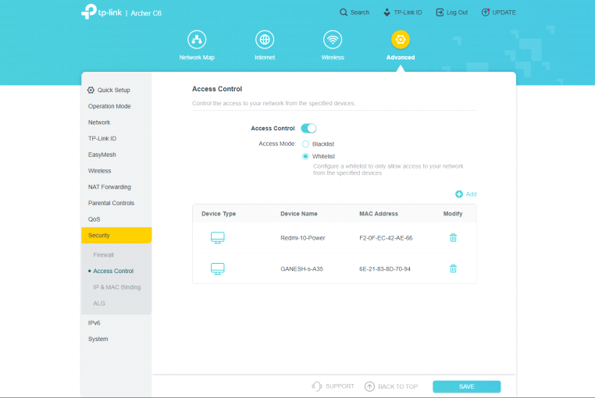
Step-7: In Access mode ,enable Whitelist and click on add , to connect the devices to wifi router.
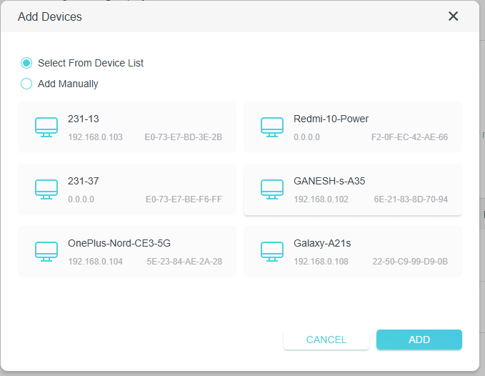
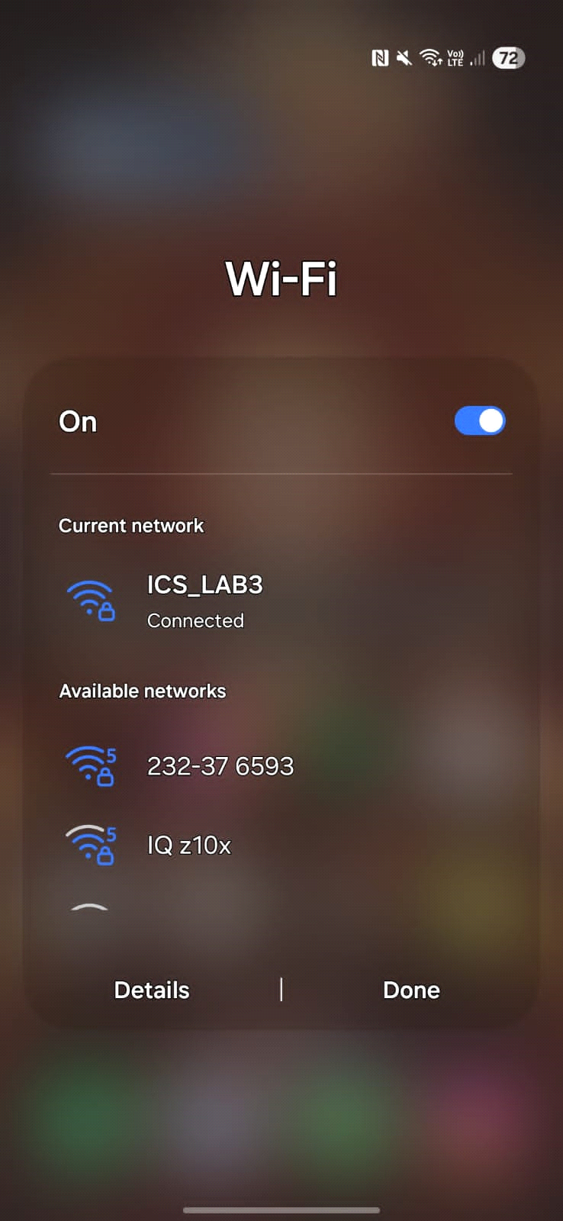
Step8:In Access mode,enable the blacklist to block the devices that are connected to provide wifi security.
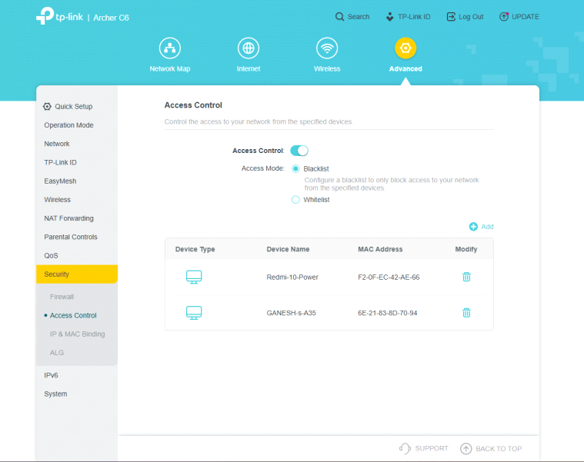
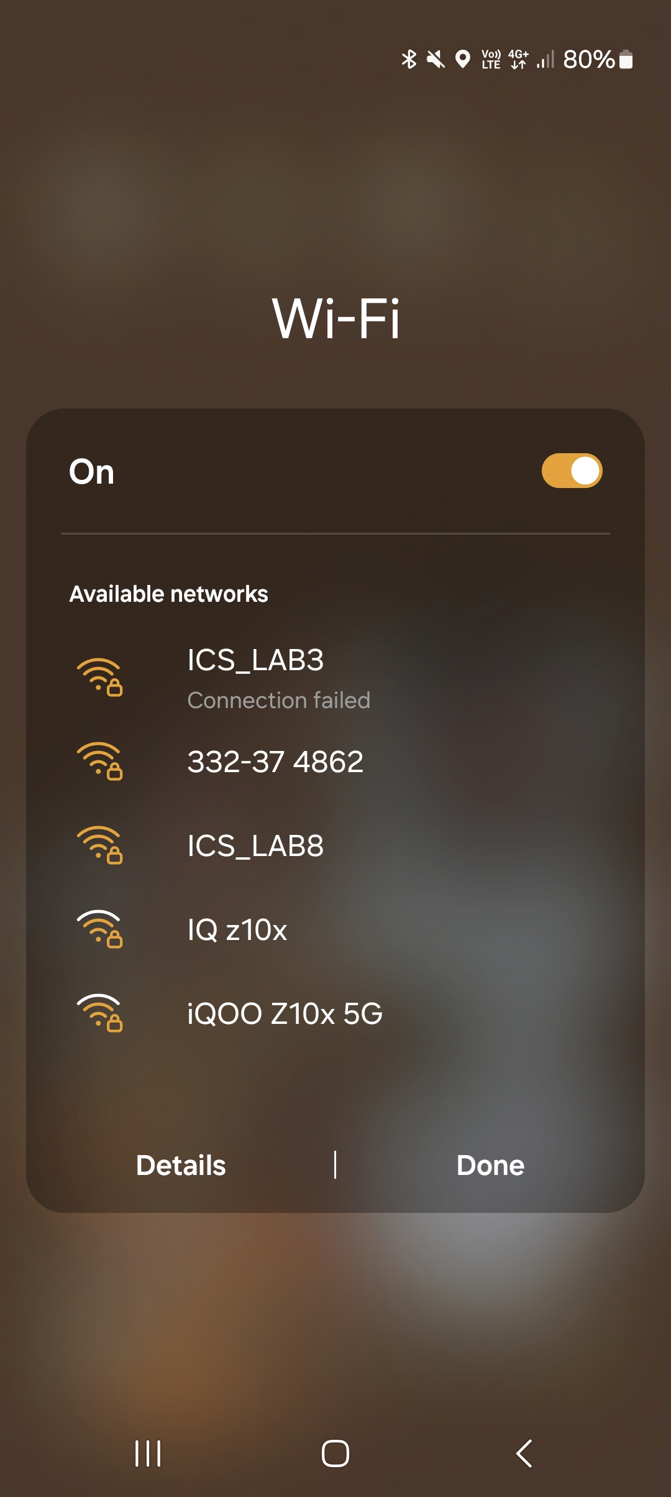
Step-9: In security, click on IP & MAC Binding and enable it.
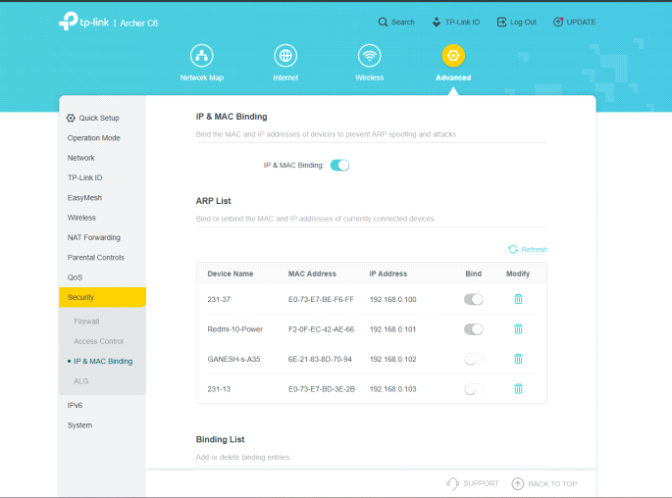

Step-10: Device Information
